**Experiment: 7**

**Aim:** Implement React Routing for navigating 5 different webpages. Design a responsive navbar in ReactJS by using media queries, Material-UI/React-Bootstrap..

1. Install react-router-dom package for routing using the command: **npm i reactrouter-dom.**

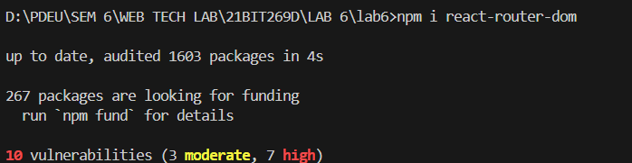

1. Create a folder named component in src folder and add 4 different files given below with their respective folders.

Different files in the component folder:

* + About.js
  + Contact.js
  + Profile.js
  + PNF.js

1. Edit the function App () and return <BrowserRouter> which contains <Routes> tag that contains **Route Path = ‘/path of the component’** and **element = ‘component of the given path’.**

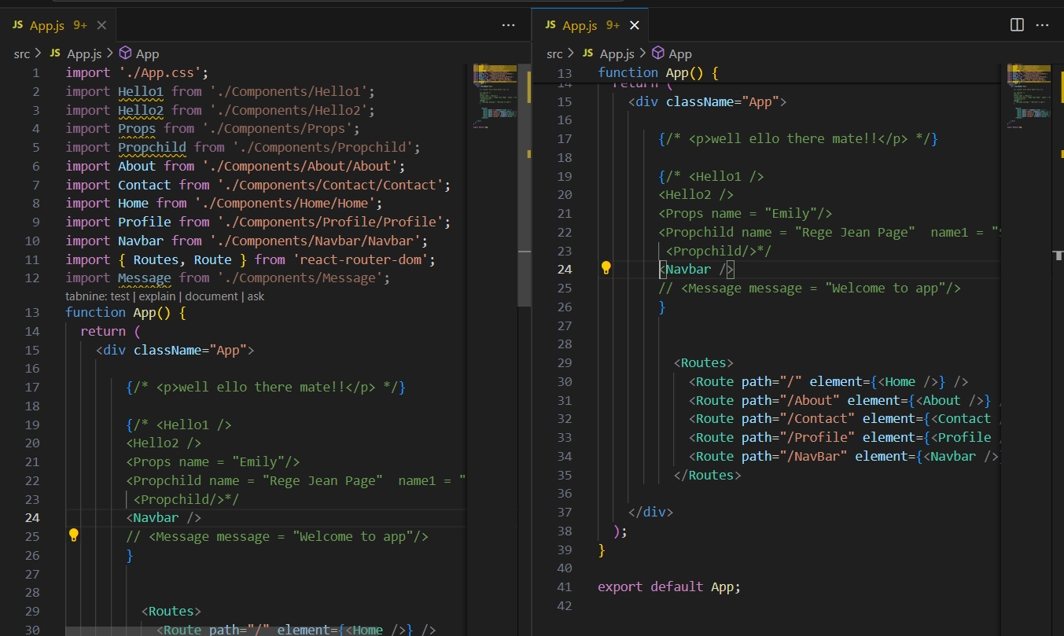

**Output:**

Navigation Bar





Contact Page

